LabVIEW: General Testing
TestStand Version: 3.5,4.0
Author: Rick Francis
Feature Spec: N/A
Dependencies: Current LabVIEW

Test Category: [Acceptance Testing]

Description
This test plan touches on all of the functionality TestStand and LabVIEW includes. It is a good sanity check for builds.

Preparation
- Install current LabVIEW and TestStand- either order should work.

Validation
- Creating a VI from TestStand
  - Start the sequence editor, select configure>Adapters… select the LabVIEW adapter and insure the LabVIEW development system is the current server.
  - Insert LV action into a new sequence’s main step group
  - Specify module if 3.5 or earlier or go to module for 4.0 or later and enter action.vi for the path and click create VI button.
  - On the created VI- right click on Report Text and create a constant, type This should appear in the report in your constant.
  - Drop a while loop add a stop button and a wait ms multiple in it so you’re your diagram looks like the following: 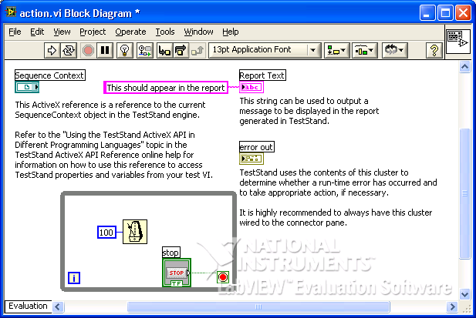
  - Insure that the stop button is visible on the front panel.
  - Save and close the VI
  - Back in TestStand Check the Show VI front Panel When Called OK dialog if TS 3.5 or earlier.
  - Save and execute the sequence using single pass- the VI’s front panel should appear click the stop button it should close it, verify the step report contains This should appear in the report
  - Right click on the Action step and select Edit code…
  - Verify that the correct VI is loaded and is editable- change the constant going into the report save the VI and re-run the sequence Verify the report string has changed.
- Getting VI Template from a pre-made VI & partial cluster passing
  - Drop a pass fail step
  - Specify module if 3.5 or earlier or go to module for 4.0 or later
  - For the VI path browse to Read My Prototype.vi (//TestStand/WebPages/TestCases/LVBuildValidation/Media/)
  - Enter Step.Result.PassFail for the Boolean out’s value
  - OK Dialog if TS 3.5 or earlier and save sequence
  - Run the sequence single pass and insure the pass/fail step passes.
  - Drop a numeric limit test
  - Specify module if 3.5 or earlier or go to module for 4.0 or later
  - Use MRU list to select Read My Prototype.vi for the path.
  - Enter Step.Result.Numeric in the Value field of Cluster out.Numeric
  - Enter Step.Result.ReportText in the Value field of Cluster out.String
  - In the Cluster.Numeric uncheck the default value and in place of 3.14159 enter 5.
  - OK Dialog if TS 3.5 or earlier and save sequence
  - Validate that the numeric limit test returns 5. Validate the default string abc is in the report text.
- Calling an Express VI
  - Drop a String Value Test step
  - Specify module if 3.5 or earlier or go to module for 4.0 or later
  - If 3.5 or earlier change VI type to Express
  - Select an express VI- (menu may take a while to build) Programming->String->Build String
  - In Text with Parameter in Percents enter A%B%C%D% and press OK
  - In TestStand uncheck the default checkbox from Beginning Text and enter Begin for its value.
  - Uncheck the default checkbox from B and enter String for its value.
  - Uncheck the default checkbox from D and enter Test for its value.
  - Enter Step.Result.String for the Result’s value.
  - OK Dialog if TS 3.5 or earlier and save sequence
  - Change the limits to BeginAStringCTest
  - Save sequence and run it.
  - Verify the string test passes.
- Debugging
  - Set a break point on the Pass/Fail Test, run main sequence
  - Step into Pass/Fail Test
  - VI’s front should appear execution should be paused. Go to block dialog with Ctrl-E
  - Turn on the Highlight Execution (toolbar light bulb button)
  - Start the VI executing using by clicking on the toolbar run icon (arrow icon)
  - You should see values travel down the wire, when the VI is done executing it should be paused. Click on the return to caller toolbar button.
  - You should be back in the sequence editor pointing to Numeric Limit test.
  - Try stepping over (F10)- you should step to string value test.
  - Try resume button the execution should finish.
  - Execute the sequence single pass
  - Step into pass fail test
  - Change the Boolean out to false by clicking on it and press the return to caller button
  - Verify that the step fails (pressing return to caller will skip executing the VI)
  - Execute the sequence single pass.
  - Change the Boolean out to true by clicking on it and press the return to caller button
  - Verify that the step passes (pressing return to caller will skip executing the VI)

- LV RTE
  - Start the sequence editor, select configure>Adapters… select the LabVIEW adapter and insure the LabVIEW runtime engine (same version as development system) is the current server.
  - Try running your sequence, insure that it passes.
  - Try stepping into a step (it should step over step into not supported with RTE)
Note: Running the LV UI in LV allows you to step into code if the RTE selected matches the LV version.
  - Switch the server back to the LV Development System.
- LabVIEW Full OI Running as VIs in LV
  - In LabVIEW 8.0 or later load open <TestStand>\UserInterfaces\NI\Full-Featured\LabVIEW\ TestExec.llb\Full OI - Top-Level VI.vi and run it.
  - Load the test sequence you created about and try to execute it.
  - Try doing the debugging test as well.
  - Try making the OI editable by selecting the sequence view and pressing control+Shift+Alt+Insert (TestStand 4.0 and later debug mode).
  - Try configuring the Express VI- change the output and validate the sequence fails
  - Edit the limits and make the sequence pass again.
  - Start the sequence editor, select configure>Adapters… select the LabVIEW adapter and insure the LabVIEW runtime engine (same version as development system) is the current server.
  - Run your sequence and insure it passes.
  - Switch the server back to the LV Development System.
- LabVIEW Full OI Running as executable
  - In LabVIEW 8.0 or later load open project and browse to <TestStand>\UserInterfaces\NI\Full-Featured\LabVIEW\ Build Script.lvproj
  - In Build Specifications right click on TestExec.exe and select Build.
  - Right click again and select run
  - Load the test sequence you created about and try to execute it.
  - Try doing the debugging test as well.
  - Try making the OI editable by selecting the sequence view and pressing control+Shift+Alt+Insert (TestStand 4.0 and later debug mode).
  - Try changing the value passed into the numeric limit test.
  - Run the sequence and insure the change is in effect. Start the sequence editor, select configure>Adapters… select the LabVIEW adapter and insure the LabVIEW runtime engine (same version as development system) is the current server.
  - Run your sequence and insure it passes.
  - Switch the server back to the LV Development System.
- Verify LV API versions
  - Open VIs in <TestStandPublic>/AdapterSupport/LabVIEW ensure they are compiled with the minimum LV version supported (for 2014 32 bit LV 2009 64 bit LV 2013SP1)

National Instruments Confidential
Copyright © 2005 National Instruments Corporation

